1)

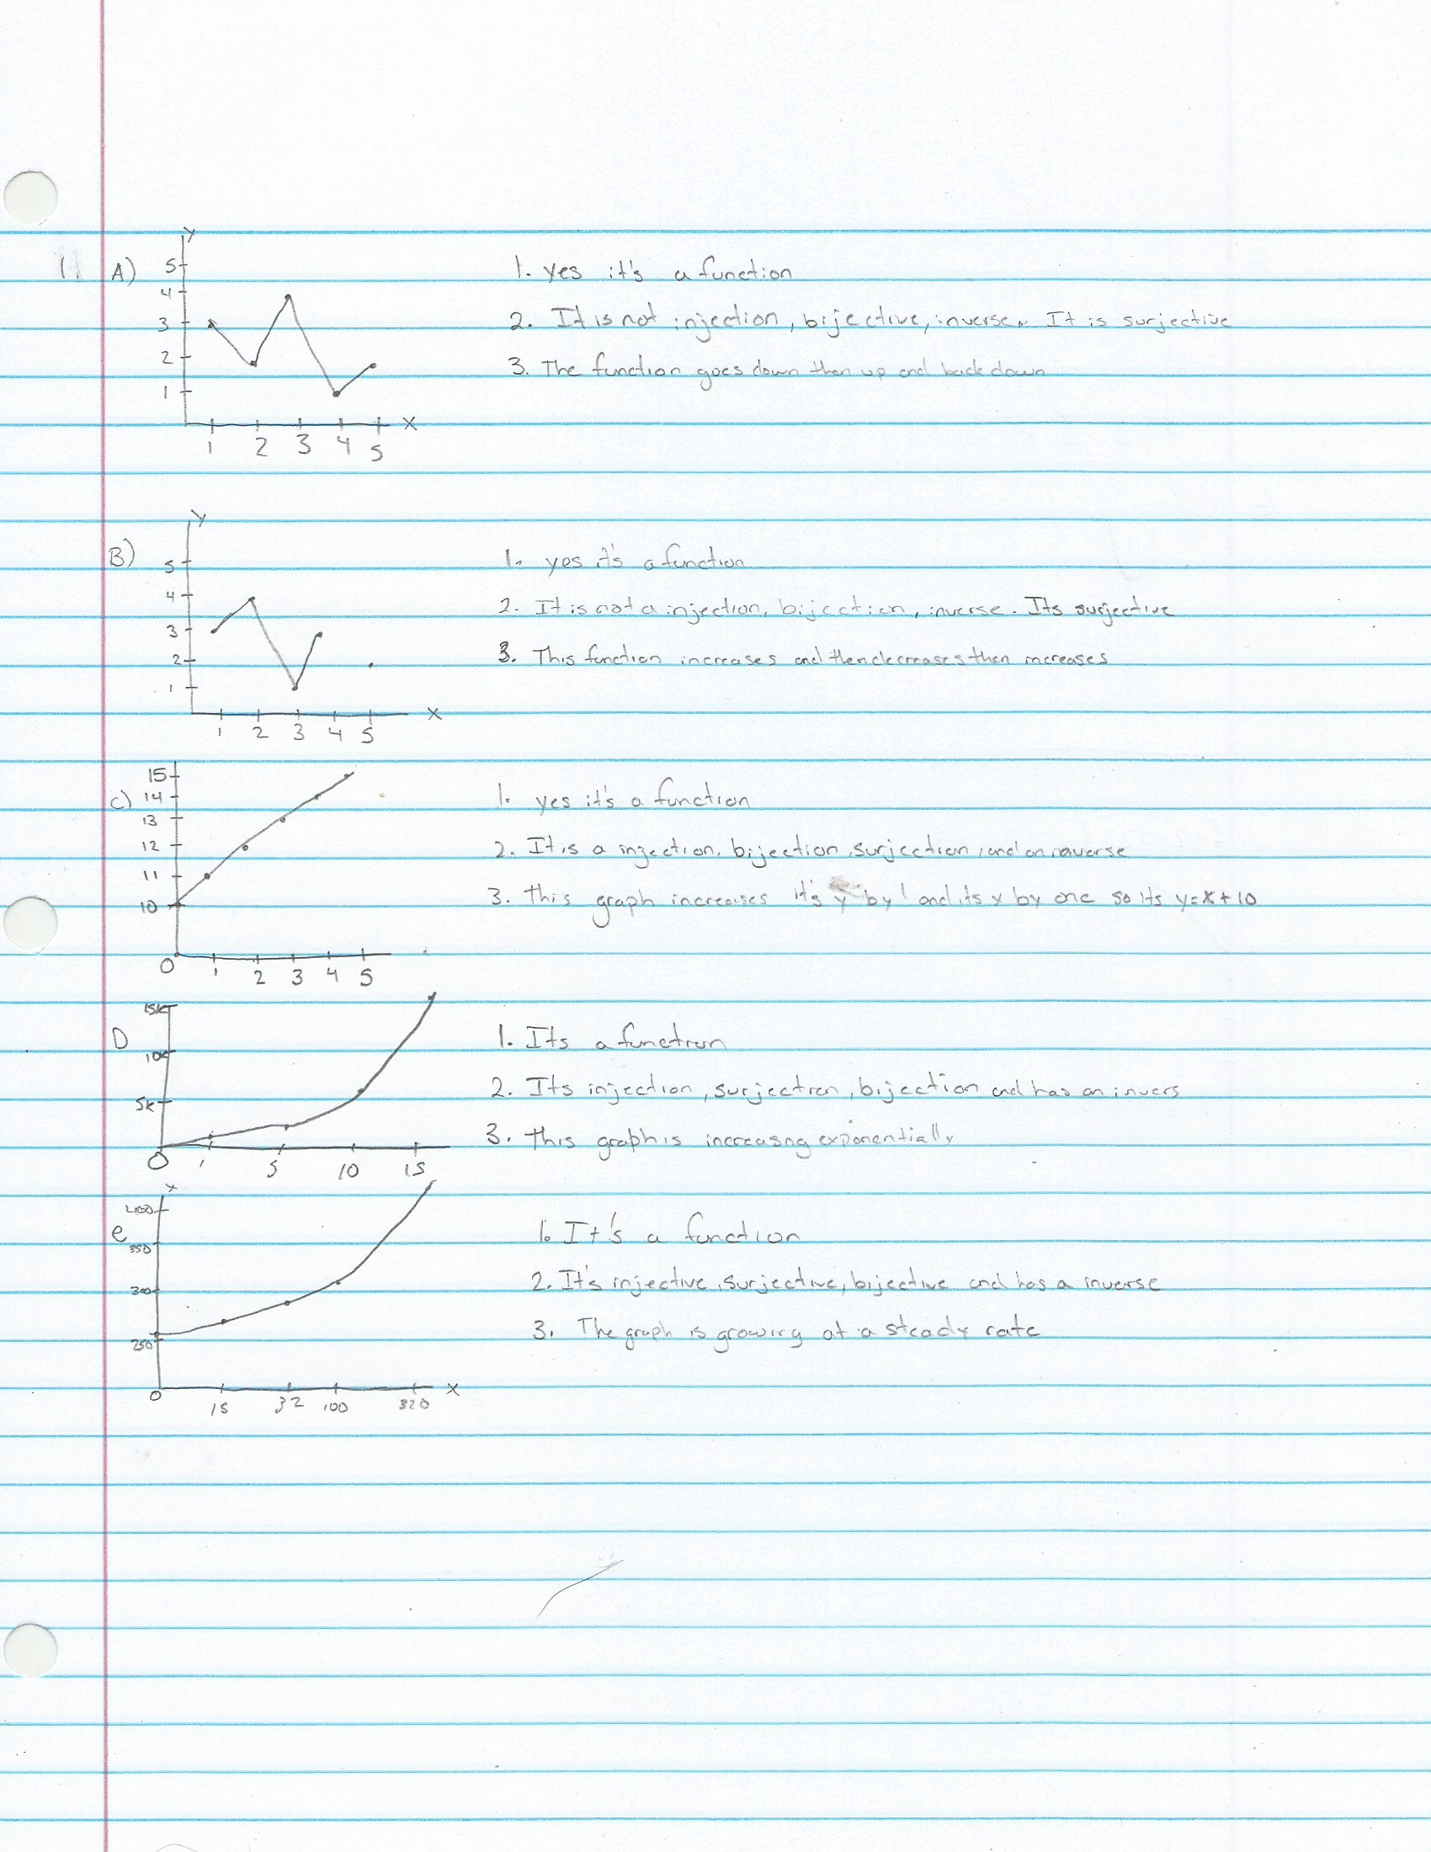

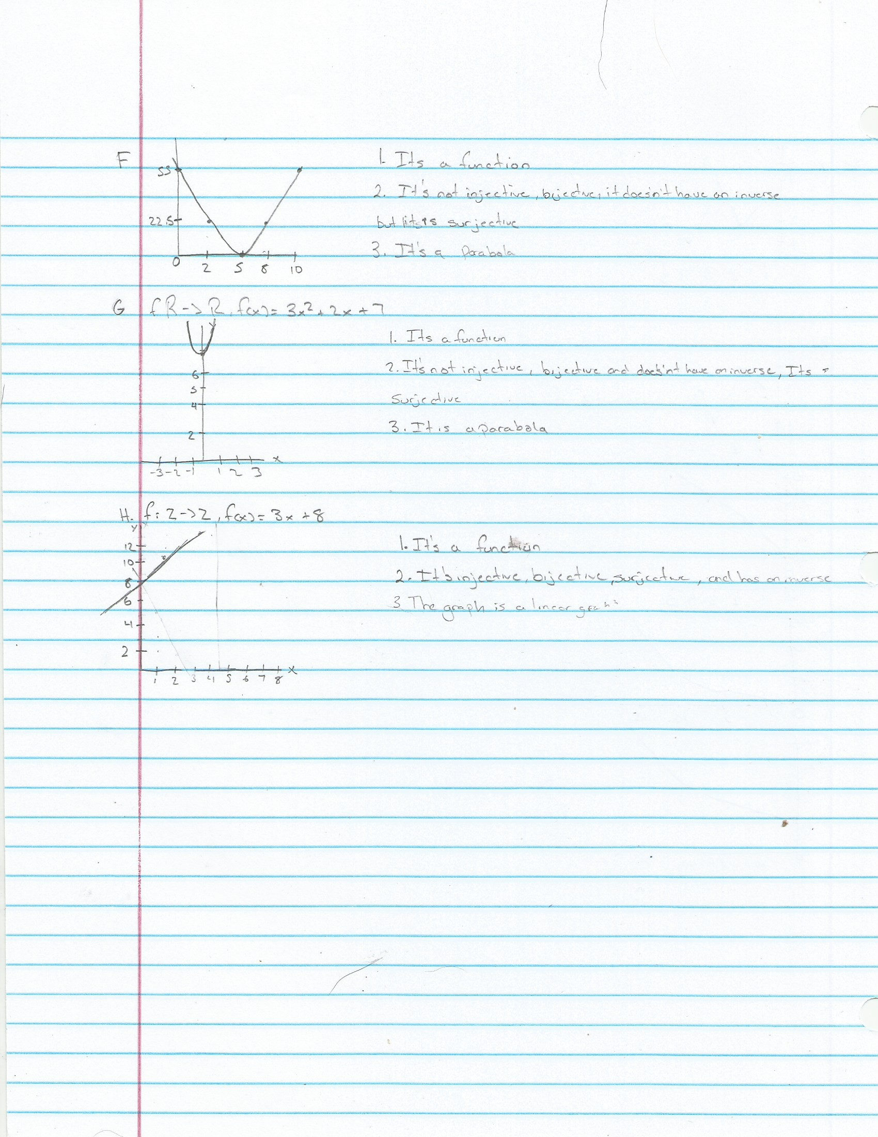

2.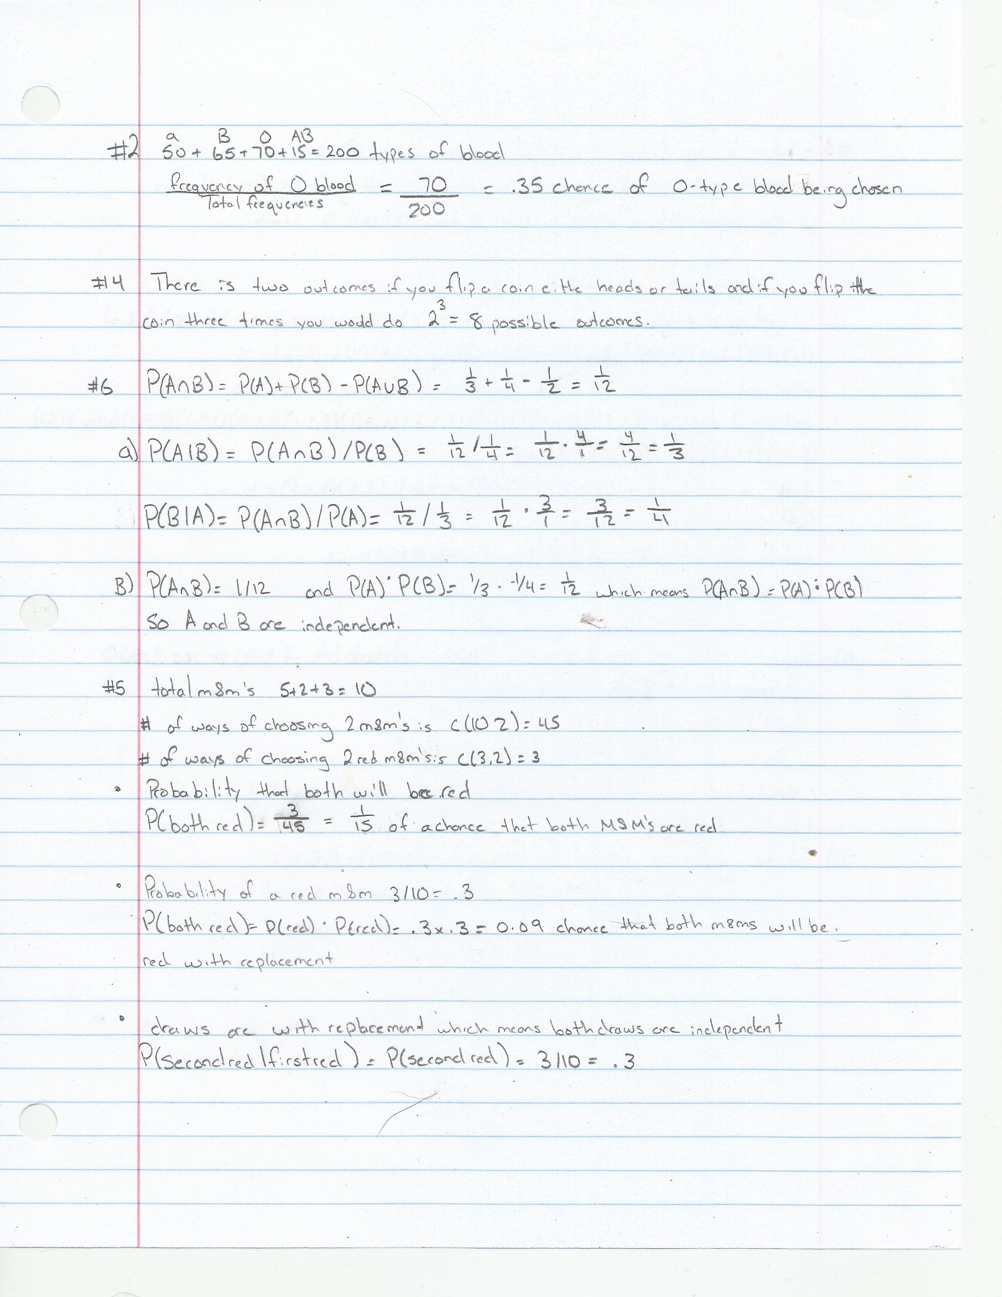

3.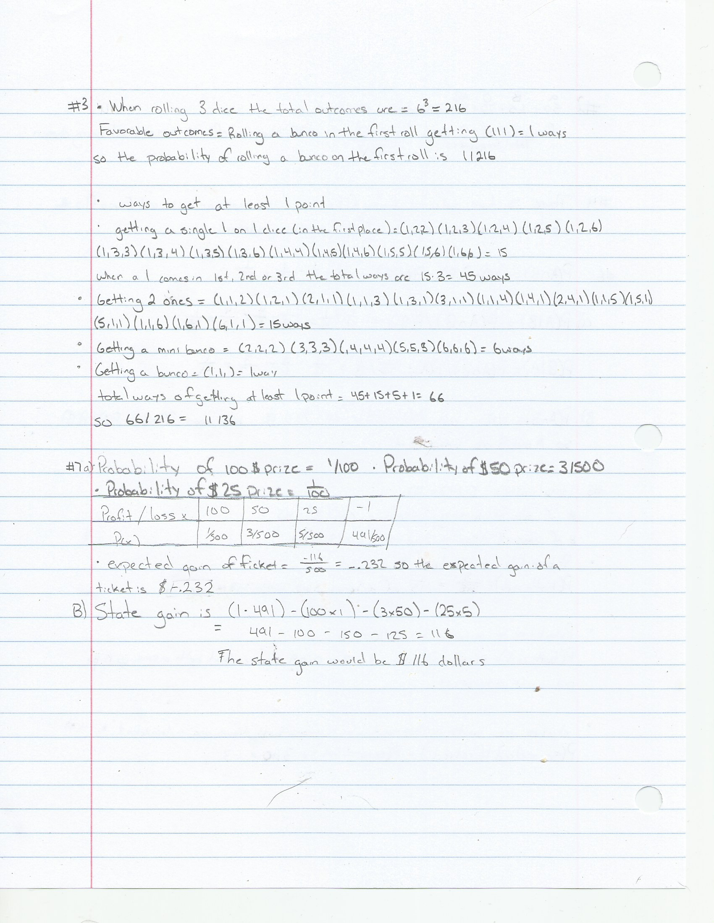

4.

5.

6. 

7.

8.

a)

#include <iostream>

#include <cstdlib> // this will allow the use of rand()

#include <ctime> // This will allow the time of time()

using namespace std;

int main() {

srand(time(0));

int heads = 0;

int tails = 0;

int black = 0;

int red = 0;

int heart = 0;

int spade = 0;

int club = 0;

int diamond = 0;

int roll;

int head = 0;

for (int i = 1; i < 1001; i++) {

roll = (rand() % 2) + 1;

cout << roll << '\t';

if (roll == 1) {

heads++;

}

if (roll == 2) {

tails++;

}

}

for (int i = 1; i < 1001; i++) {

roll = (rand() % 2) + 1;

cout << roll << '\t';

if (roll == 1) {

black++;

}

if (roll == 2) {

red++;

}

}

for (int i = 1; i < 1001; i++) {

roll = (rand() % 4) + 1;

cout << roll << '\t';

if (roll == 1) {

heart++;

}

if (roll == 2) {

spade++;

}

if (roll == 3) {

club++;

}

if(roll == 4) {

diamond++;

}

}

cout << endl;

cout << "Results of coin flip" << endl;

cout << "amount of heads " << heads << "/1000"<< endl;

cout << "amount of tails " << tails << "/1000"<< endl;

cout << endl;

cout << "Results of picking card color" << endl;

cout << "amount of red " << red << "/1000"<< endl;

cout << "amount of black " << black << "/1000"<< endl;

cout << endl;

cout << "Results of picking card suit" << endl;

cout << "amount of hearts " << heart << "/1000"<< endl;

cout << "amount of spades " << spade << "/1000"<< endl;

cout << "amount of clubs " << club << "/1000"<< endl;

cout << "amount of diamonds " << diamond << "/1000"<< endl;

cout << endl;

cout << "Probable frequency of flipping a coin is 500/1000 for heads and 500/1000 for tails" << endl;

cout << "Probable frequency of picking the card color is 500/1000 for the black card and 500/1000 for the red card" << endl;

cout << "Probable frequency of picking the four different card suits is 250/1000 for the heart, spade, club and diamond suit" << endl;

cout << endl;

cout << "The difference for Heads is " << 500-heads << " and the difference for tails is " << 500-tails << endl;

cout << "The difference for the red card is " << 500-red << " and the difference for the black card is " << 500-black << endl;

cout << "The difference for the spade card is " << 250-spade << " and the difference for the heart card is " << 250-heart << endl;

cout << "The difference for the club card is " << 250-club << " and the difference for the diamond card is " << 250-diamond << endl;

}

